**CREATING A NEW SPRING FRAMEWORK PROJECT WITH MAVEN AND JAVA**

The best way to create a spring project is go to this website: <https://start.spring.io/>

This is called Spring Initializer.

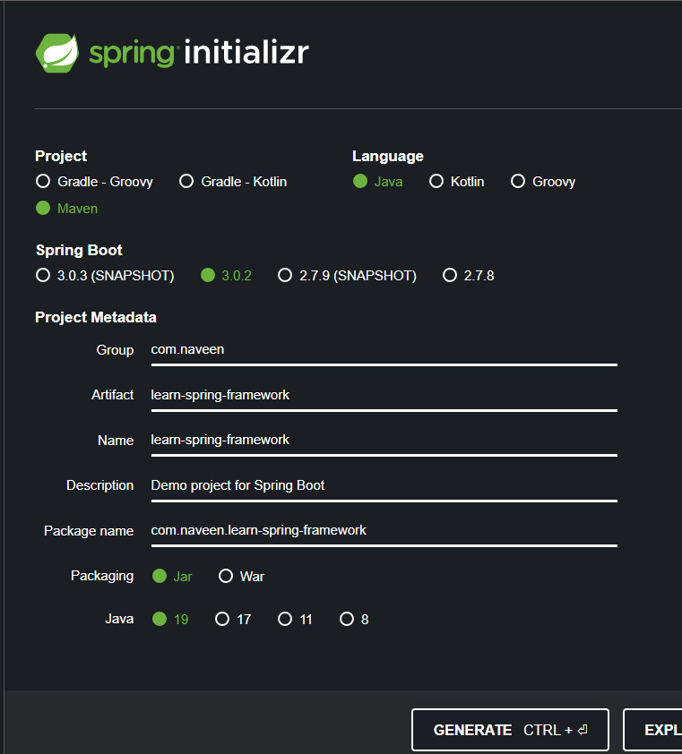

* **Note**: While choosing **Spring Boot version**, **do not use snapshot version**. Snapshot versions are **currently developed by spring boot team**, then we should not use it when we are learning something new.
* Group ID and Artifact ID are like package name and class name.
* Once click **GENERATE** button, the zip will be downloaded in our download folder. And unzip a folder to our local hard disk.

**IMPORT THE PROJECT IN ECLIPSE IDE**:

File 🡪 Import 🡪 Choose Maven 🡪 Existing Maven Project 🡪 click Next 🡪 click Browse 🡪 Select the unzipped folder 🡪 Finish.

After clicking the **finish**, we will see our project structure.

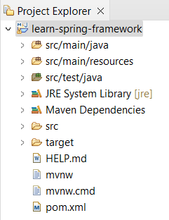

**src/main/java** 🡪 where we would be storing all our source files.

**src/main/resource** 🡪 to store all our configuration files in.

**src/test/java** 🡪 where we will write our test code.